create table review (id serial PRIMARY key ,comments VARCHAR(200), course_id int , CONSTRAINT FK_REVIEW FOREIGN KEY (course_id) REFERENCES course(id))

Many To Many

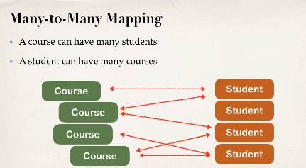

- need to track which studnet is in which course

Make use of join table

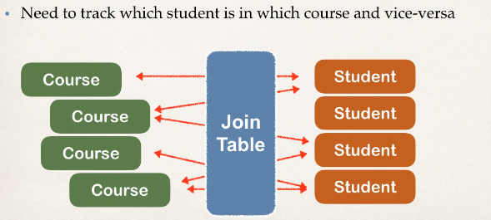

Join Table

Table that provide mapping between two tables , it has a foreign key for each table to define mapping relationship

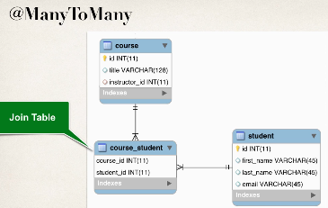

Join table examples

Develeopment Process

1 define table

2 update couse table

3 update studnet table

4 main app

Join Table : course_student;

CREATE table course_student(course_id int , student_id int , PRIMARY KEY(course_id,student_id))

Join Table: course_student - foreign keys

CREATE table course_student(course_id int , student_id int , PRIMARY KEY(course_id,student_id),

CONSTRAINT FK_COURSE_STUDENT FOREIGN KEY (course_id) REFERENCES course(id),

CONSTRAINT FK_STUDENT_COURSE FOREIGN KEY (student_id) REFERENCES student(id)

)

2 update couse Entity

@ManyToMany(fetch=FetchType.***LAZY***,cascade= {CascadeType.***DETACH***,CascadeType.***MERGE***,CascadeType.***PERSIST***,CascadeType.***REFRESH***})

@JoinTable(name="course_student",

joinColumns=@JoinColumn(name="course_id"), // refere to course_id column in course_student join table

inverseJoinColumns=@JoinColumn(name="student_id") // refere to student_id column in course_student join table

)

**private** List<Student> students;

// gettter and setter

// add convein method to add students

**public** **void** add(Student student)

{

**if**(students==**null**)

{

students=**new** ArrayList<Student>();

}

students.add(student);

}

@JoinTable

1 look at the course_id column in course_student join table

2 for the other side(inverse) look the student_id column in the course_student table

Use the information to find relation between course and student

Inverse:

In context defining relationship in the course class

The student class in another side so it is consdiered inverse

Invers refer to other side of the relationship

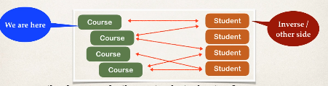

Lets do same way update student

3 Update Student

@ManyToMany(Student)

@JoinTable(name="course_student",

joinColumns=@JoinColumn(name="student_id"), // refere to student_id column in course_student join table

inverseJoinColumns=@JoinColumn(name="course_id") // refere to course_id column in course_student join table

)

**private** List<Course> courses;

// gettet and setter

4 main APp

Real World porject

-If delete a course don’t delete student NO CASCADE DELETE

-lazy loadign of student classs

- cascading saves but not deletes

select courses0_.student_id as student_1_5_0_, courses0_.course_id as course_i2_5_0_, course1_.id as id1_0_1_, course1_.instructor_id as instruct3_0_1_, course1_.title as title2_0_1_, instructor2_.id as id1_1_2_, instructor2_.email as email2_1_2_, instructor2_.first_name as first_na3_1_2_, instructor2_.instructor_detail_id as instruct5_1_2_, instructor2_.last_name as last_nam4_1_2_, instructor3_.id as id1_2_3_, instructor3_.hobby as hobby2_2_3_, instructor3_.youtube_channel as youtube_3_2_3_ from course_student courses0_ inner join basicdb.course course1_ on courses0_.course_id=course1_.id left outer join basicdb.instructor instructor2_ on course1_.instructor_id=instructor2_.id left outer join basicdb.instructor_detail instructor3_ on instructor2_.instructor_detail_id=instructor3_.id where courses0_.student_id=5

Delete Course

- confirm student not deleted

-only delete course_student relationship

Delete Student

- confirm Course not deleted

-only delete course_student relationship